Title

Author 11, Author 22

*1 Affiliation*

*2 Affiliation*

|  |
| --- |
| ABSTRACT 5-10 lines in "Abstract" style from Microsoft Word, with simple space.  Keywords list of 3-5 words, separated with commas  Mots-clefs list of 3-5 words, separated with commas |

I. INTRODUCTION

File must be in MS Word (use dedicated template). Figures and Tables must be integrated in file instead of separately provided. **Article will take place in 8 to 10 pages**. For paragraph text, use "Paragraph" style (Palatino Linotype, 10).

Languages: English or French

II. FORMATS

A. Lists and equations

Bulleted lists should look like this:

* First point
* Second point
* And so on

Numbered lists use this format:

1. First point

2. Second point

3. And so on

Equations and formulae should use equation editor and numbered consecutively with Arabic numerals in parentheses on the right-hand side of the page. They also must be separated from the text by a single space.

$y=ax+b$ $V=\frac{D}{t}$ $V=\frac{D}{t}$ (1)

B. Tables and figures

All tables should be numbered with Arabic numerals. Every table should have a caption. Heading should be placed above tables. Give a space at the bottom of it. 1 is an example of a table.

TABLE 1. **Example**

|  |  |  |
| --- | --- | --- |
| Example | Column A | Column B |
| Line A | 1 | 1 |
| Line B | 2 | 2 |
| Line C | 3 | 3 |

All figures should be numbered with Arabic numerals (1,2,3...). Every figure should have a caption. Please ensure that all figures are of 300 DPI resolutions (minimum). The figure number and caption should be typed below the illustration. For example, see.1.

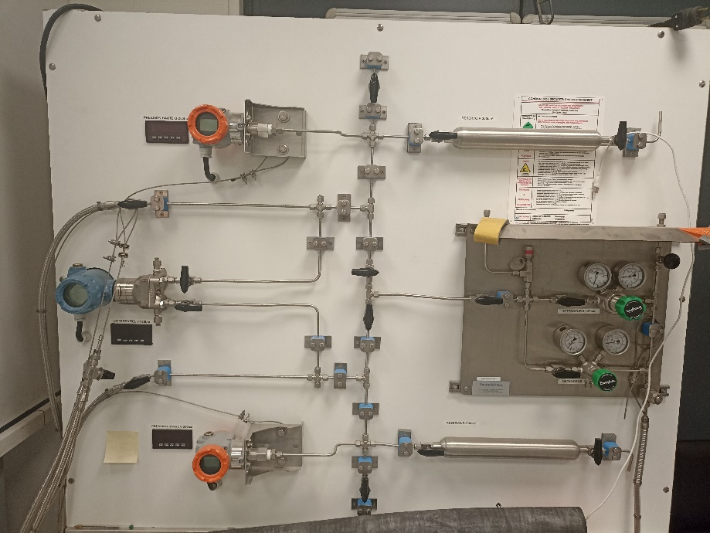

FIGURE 1. **Example**

*C. References*

In the text, use the given reference format. Here is an example: [Author1 et al., AAAA].

REFERENCES

Use style “Elsevier – Harvard (with titles)”. Some examples follow below.

Hamari, J., Koivisto, J., Sarsa, H. (2014). Does Gamification Work? -- A Literature Review of Empirical Studies on Gamification. *47th Hawaii International Conference on System Sciences*, 3025‑3034. <https://doi.org/10.1109/HICSS.2014.377>

Taillandier, F., Adam, C. (2018). Games Ready to Use: A Serious Game for Teaching Natural Risk Management. *Simulation & Gaming*, 49(4), 441‑470. <https://doi.org/10.1177/1046878118770217>